1. GUI Program to display the current mouse coordinates on the window.

import javax.swing.*;

import java.awt.*;

import java.awt.event.*;

public class MouseLocation extends JFrame implements MouseMotionListener {

JLabel label;

public MouseLocation() {

setTitle("Mouse Coordinate Tracker");

setSize(400, 300);

setLayout(null);

setDefaultCloseOperation(EXIT_ON_CLOSE);

label = new JLabel("Move the mouse");

label.setBounds(100, 100, 200, 30);

label.setFont(new Font("Arial", Font.PLAIN, 16));

add(label);

addMouseMotionListener(this);

setVisible(true);

}

public void mouseMoved(MouseEvent e) {

int x = e.getX();

int y = e.getY();

label.setText("Mouse at: (" + x + ", " + y + ")");

}

public void mouseDragged(MouseEvent e) {

// Optional: you can update coordinates while dragging if needed

mouseMoved(e);

}

public static void main(String[] args) {

new MouseLocation();

}

}

**OUTPUT**

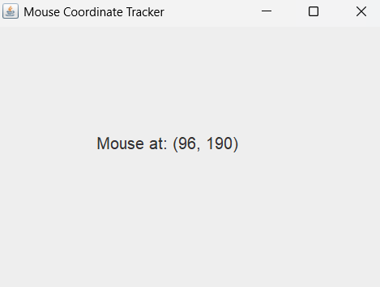

1. GUI Program to implement a simple Timer (using background events). Include a Start and Stop button to control the timer.

import javax.swing.*;

import java.awt.*;

import java.awt.event.*;

public class SimpleTimer extends JFrame implements ActionListener {

JLabel timeLabel;

JButton startBtn, stopBtn;

Timer timer;

int seconds = 0;

public SimpleTimer() {

setTitle("Simple Timer");

setSize(300, 200);

setLayout(null);

setDefaultCloseOperation(EXIT_ON_CLOSE);

timeLabel = new JLabel("Time: 0 sec");

timeLabel.setBounds(90, 30, 150, 30);

timeLabel.setFont(new Font("Arial", Font.BOLD, 18));

add(timeLabel);

startBtn = new JButton("Start");

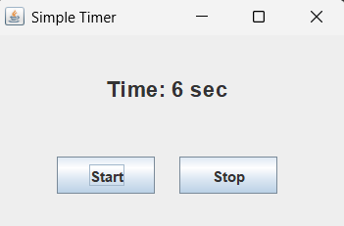 startBtn.setBounds(50, 100, 80, 30);

add(startBtn);

stopBtn = new JButton("Stop");

stopBtn.setBounds(150, 100, 80, 30);

add(stopBtn);

startBtn.addActionListener(this);

stopBtn.addActionListener(this);

// Timer: fires every 1000 ms (1 sec), increments seconds

timer = new Timer(1000, new ActionListener() {

public void actionPerformed(ActionEvent e) {

seconds++;

timeLabel.setText("Time: " + seconds + " sec");

}

});

setVisible(true);

}

public void actionPerformed(ActionEvent e) {

if (e.getSource() == startBtn) {

timer.start();

} else if (e.getSource() == stopBtn) {

timer.stop();

}

}

public static void main(String[] args) {

new SimpleTimer();

}

}

**output**

1. Create a GUI with a JComboBox containing image names. On selection, display the corresponding image using a JLabel and ItemListener.

import javax.swing.*;

import java.awt.*;

import java.awt.event.*;

public class ImageSelector extends JFrame implements ItemListener {

JComboBox<String> imageList;

JLabel imageLabel;

String[] imageNames = {"Image1", "Image2", "Image3"};

String[] imagePaths = {"image1.jpeg", "image2.jpeg", "image3.jpeg"};

public ImageSelector() {

setTitle("Image Selector");

setSize(500, 400);

setLayout(null);

setDefaultCloseOperation(EXIT_ON_CLOSE);

imageList = new JComboBox<>(imageNames);

imageList.setBounds(150, 20, 200, 30);

add(imageList);

imageLabel = new JLabel();

imageLabel.setBounds(100, 70, 300, 250);

imageLabel.setHorizontalAlignment(JLabel.CENTER);

add(imageLabel);

imageList.addItemListener(this);

setVisible(true);

}

public void itemStateChanged(ItemEvent e) {

if (e.getStateChange() == ItemEvent.SELECTED) {

int index = imageList.getSelectedIndex();

ImageIcon icon = new ImageIcon(imagePaths[index]);

Image img = icon.getImage().getScaledInstance(300, 250, Image.SCALE_SMOOTH);

icon = new ImageIcon(img);

imageLabel.setIcon(icon);

}

}

public static void main(String[] args) {

new ImageSelector();

}

}

**output**

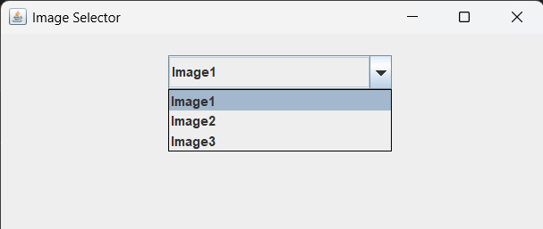

4.GUI with a JTextArea and a label. As the user types, show the character count and word count in real-time using a KeyListener.

import javax.swing.*;

import java.awt.*;

import java.awt.event.*;

public class TextCounterGUI extends JFrame implements KeyListener {

private JTextArea textArea;

private JLabel countLabel;

public TextCounterGUI() {

setTitle("Live Text Counter");

setSize(400, 300);

setDefaultCloseOperation(JFrame.EXIT_ON_CLOSE);

setLocationRelativeTo(null);

textArea = new JTextArea();

countLabel = new JLabel("Characters: 0 | Words: 0");

textArea.addKeyListener(this);

setLayout(new BorderLayout());

add(new JScrollPane(textArea), BorderLayout.CENTER);

add(countLabel, BorderLayout.SOUTH);

setVisible(true);

}

public void keyPressed(KeyEvent e) {

// Not used, but must be implemented

}

public void keyReleased(KeyEvent e) {

updateCounts();

}

public void keyTyped(KeyEvent e) {

// Not used, but must be implemented

}

private void updateCounts() {

String text = textArea.getText();

int charCount = text.length();

int wordCount = text.trim().isEmpty() ? 0 : text.trim().split("\\s+").length;

countLabel.setText("Characters: " + charCount + " | Words: " + wordCount);

}

public static void main(String[] args) {

SwingUtilities.invokeLater(TextCounterGUI::new);

}

}

**Output**

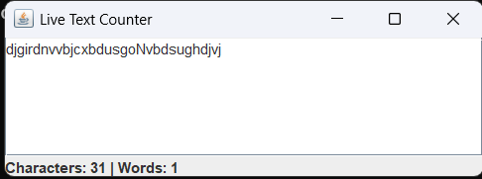

1. Write Java GUI Program using Swing to change background on selecting color.

import java.awt.*;

import java.awt.event.*;

import javax.swing.*;

class bgcolor extends JFrame implements ActionListener{

JButton B1,B2,B3;

public bgcolor(){

B1=new JButton("Red");

B2=new JButton("Green");

B3=new JButton("Blue");

B1.setBounds(20,20,80,30);

B2.setBounds(120,20,80,30);

B3.setBounds(220,20,80,30);

add(B1);

add(B2);

add(B3);

B1.addActionListener(this);

B2.addActionListener(this);

B3.addActionListener(this);

setLayout(null);

setSize(400,400);

setVisible(true);

setDefaultCloseOperation(JFrame.EXIT_ON_CLOSE);

}

public void actionPerformed(ActionEvent e)

{

if(e.getSource()==B1){

getContentPane().setBackground(Color.RED);

}

else if (e.getSource()==B2){

getContentPane().setBackground(Color.GREEN);

}else

{

getContentPane().setBackground(Color.BLUE);

}

}

public static void main(String args[])

{

bgcolor r=new bgcolor();

}

}

**Output**

